Rotary Club of Kathmandu Mid-Town
Breakfast Chatter




13 January 2012 The Weekly Bulletin of Rotary Club of Kathmandu Mid-Town Bc-1.13/011-12

District: 3292 Web: www.rotarymidtown.org.np Club Id : 26776

JANUARY IS THE ROTARY AWARENESS MONTH
Awareness is an important part of the Rotary work that can be divided into two parts.
It is imperative that members are well aware of Rotary’s goals – that Rotary is an organization that works for peace and better understanding between people.
The other part of Rotary awareness is the sharing of information outside of our organization.

6 January, Friday:
Guest Speaker for the day was Mr Dawa Steven Sherpa, son of our Club friend Rtn Jo Logghe. He provided an interesting account of Great Himalayan Trek.
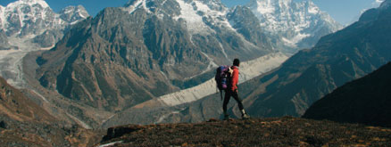
The GHT is the longest and highest alpine walking track in the world winding 4500 kms through the tallest mountain ranges and most isolated communities from Tibet to Pakistan. The Nepal section of the GHT offers a kaleidoscope of experiences. A World First – the first trek of Nepal’s Great Himalaya Trail was completed in July 2011 by Greg Baggage of Australia and Toni Wilson of England!
The trail, which can be undertaken in one continuous trek of 157 days, will traverse the country from east to west. Since people simply don’t have the luxury of this sort of time for the adventures, GHT is crafted into seven treks that will interlink to make up the full traverse. The beauty of each is that they all offer something completely different.
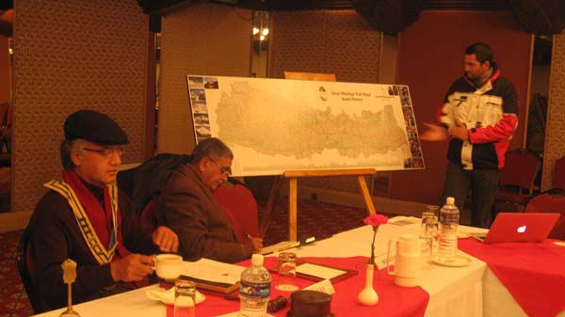 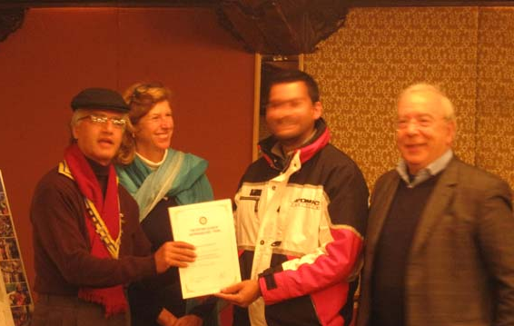.
Guest speaker Dawa Steven Sherpa giving talk on President Som handing over certificate of
the "Great Himalayan Trek". appreciation to Guest Speaker Steven Sherpa flanked by Rtn Lisa and Rtn Alexander.

Weekly Meetings and Programs :
Date | Program/Speaker | Program/Topics of Presentation
13 January 2012 | Shuvani Singh | Kathmandu Literary Jatra and Managing Literary Events
20 January 2012 | Kamala Sharma, Volunteer's Hand Nepal | Poor orphans
27 January 2012 | Kiran Joshi, CEO of Incessant Rain | Animated films in Nepal

Gorkha-Lamjung Girl Child project :
Program for visiting Gorkha and Lamjung project sites for distribution of student stationeries and school dresses to girl child students, handing over sewing machines for tailoring training, material for candle making training, and seed money for goat farming program:
Departure Kathmandu for Gorkha on Saturday 4 Feb 2012 at 8:00 hrs.
After completion of program in Gorkha, night stay at Bandipur.
Departure Bandipur for Lamjung on Sunday 5 Feb 2012 at 8:00 hrs
After completion of program in Lamjung, set off for Kathmandu;
Arrival Kathmandu at 19:00 hrs same day.
For further detail please contact Rtn Arun, Chairperson, Service Projects.

District Conference:
4th District Conference of RI District 3292, inaugurated jointly by RIPR Rtn Jayant Kulkarni and RI Director Rtn Shekhar Mehta on Thursday, 5th January by lightening panas, in Birendra Sabha-griha, Biratnagar, concluded on Saturday 7th January 2012. It is reported that there was record registration of 782 participants attending the Conference. All Rotary clubs (80) of the country were represented in the Conference.
On 7th January, the concluding day of the Conference, our fellow distinguished Rotarian Kul Chandra Gautam was the key note speaker. He provided key note address on “Rotary Nepal: Promoting peace and development through sports.”

RYLA:
RYLA 2012 is scheduled to be held on 3-7 February 2012 at Chetana Kendra (Gramin Training Center) in Dhulikhel, Budol-Kavre. The RYLA is organized for young people of age-group 14-18 years nominated by Rotary clubs. Two rotaracts/interacts from our club will be participating in the up-coming RYLA.

Top five Rotary stories of 2011
From the tsunami in Japan to the launch of strategic partnerships that will help Rotary expand its reach, 2011 was an eventful year for Rotary International and Rotarians. As the year winds down, we share our list of the top five Rotary news events of 2011.
3. The fight against polio
India has been making great strides toward polio eradication in 2011, with only one case of the virus reported from January through early December. Rotarians helped administer bivalent oral polio vaccine to more than 35 million children in the country during a Subnational Immunization Day on 13 November.
On 20 November, a team of Rotarians from District 3700 (Korea) served in a health camp in Meerut, Uttar Pradesh, where children were immunized against the disease. The camp was organized by Indian Rotarians in cooperation with local health officials and UNICEF.
Rotarians also worked to get out the message about polio eradication for World Polio Day in October. In Australia, Rotarians and the Global Poverty Project carried out a petition drive to persuade world leaders to fully fund the critical work of the Global Polio Eradication Initiative. Almost 25,000 supporters signed the petition, resulting in a A$20,000 (US$20,700) contribution to Rotary's US$200 Million Challenge by the Rotary Club of Crawley, Western Australia, which had offered to donate A$1 for each signature.
In Perth, the Global Poverty Project's End of Polio Concert on 28 October raised additional funds. The concert coincided with the Commonwealth Heads of Government Meeting in the city; Rotarians had teamed up with the group to urge government leaders to put polio eradication on the agenda. After the meeting, the governments of Australia, Canada, and Nigeria, along with the Bill & Melinda Gates Foundation, announced a combined pledge of more than US$100 million to support polio eradication efforts.
(To be Cont’d) Source: Rotary International News

We need a planned, imaginative, modern-day presentation of the Rotary story to the
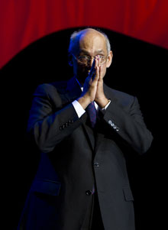
world. Newspapers and magazines carry enough stories of the bad. It’s time to tell
the stories of the good. The way we tell it may differ from place to place, country to
country. But it needs to be told, because we surely do things worth telling.
RI President Kalyan Banerjee

On Lighter Side :
Click here ⇩


A thought for the day:
It is very easy to defeat someone, but it is very hard to win some !
Dr Abdul Kalaam


The longest traffic jam in the world recorded in China.
Letter to the editor:
Two email comments were received on BC # bc-1.6/011-12:
a) Dear All,
under "Do you know you" wrote in the Breakfast Chatter: Boil it, cook it properly or forget it.
I always thought the saying goes as follows: boil it, peel it or leave it.
Yours
Verena
b) Dear All,
One of my friend used to say that "life is potato boilt it and do not eat it".
Regards.
Shyam

Please send project/activity information, suggestions and photos etc to :
BC Editor: RR Shrestha email: rryes@wlink.com.np

13 January 2012 The Weekly Bulletin of Rotary Club of Kathmandu Mid-Town bc-1.13/011-12

